|  |  |
| --- | --- |
| **Name** | Umar Hayyat |
| **Roll No.** | 360 |

**Lab No. 9**

**Use of list commands**

**Objective:**

* How to find prime numbers in a given range using a list.
* How to sort data using bubble sort function.

**Task No 1:**

A prime integer is any integer greater than 1 that is evenly divisible only by itself and 1. The Sieve of Eratosthenes is a method of finding prime numbers. It operates as follows:

a) Create a list with all elements initialized to 1 (true). List elements with prime subscripts will remain 1. All other list elements will eventually be set to zero.

b) Starting with list element 2, every time a list element is found whose value is 1, loop through the remainder of the list and set to zero every element whose subscript is a multiple of the subscript for the element with value 1. For list subscript 2, all elements beyond 2 in the list that are multiples of 2 will be set to zero (subscripts 4, 6, 8, 10, etc.); for list subscript 3, all elements beyond 3 in the list that are multiples of 3 will be set to zero (subscripts 6, 9, 12, 15, etc.); and so on.

When this process is complete, the list elements that are still set to 1 indicate that the subscript is a prime number. These subscripts can then be printed. Write a program that uses a list of 1000 elements to determine and print the prime numbers between 2 and 999. Ignore element 0 of the list.

**Code:**

y=[ ]

for x in range(1000):

y.append(1)

for z in range(2,1000):

if(y[z]==1):

for w in range(z+1,1000):

if(w%z==0):

y[w]=0

for v in range(2,1000):

if(y[v]==1):

print(v,end=" ")

**Output:**

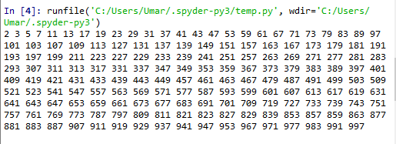

Figure 9.1: Output of Task 1

**Task No. 2:**

Sorting data is one of the most important computing application. In the bubble sort the smaller values gradually “bubble” their way upward to the top of the list like air bubbles rising in water, while the larger values sink to the bottom of the list. The process that compares each adjacent pair of elements in a list in turn and swaps the elements if the second element is less than the first element is called a pass. On each pass, successive pairs of elements are compared. If a pair is in increasing order, bubble sort leaves the values as they are. If a pair is in decreasing order, their values are swapped in the list. After the first pass, the largest value is guaranteed to sink to the highest index of a list. After the second pass, the second largest value is guaranteed to sink to the second highest index of a list, and so on. Write a program that uses function bubbleSort to sort the items in a list.

**Code:**

x =[22,45,21,48,65]

print("unsorted list",x)

for i in range(len(x)-1):

for k in range(len(x)-1-i):

if x[k]>x[k+1]:

x[k],x[k+1]=x[k+1],x[k]

print(x)

else:

print(x)

print()

print("sorted list:",x)

**Output:**

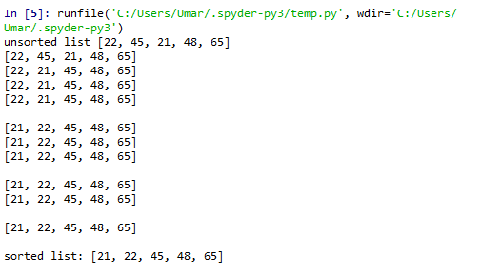

Figure 9.2: Output of Task 2

**Conclusion:**

I have learnt the using of Eratosthenes method. I also learnt how to print prime numbers in a given range of numbers. I learnt how to sort data using bubble sort function.